**The Translational Cancer Research Day**

**May 8th, 2025**

**8.00 – 8.30** Registration

**8.30 – 8.40** Introduction

**Cancer Cell Invasion and Metastases**

**8.40 – 9.05** The Reversibility of Ovarian Carcinoma Treatment Resistance**Håkan Hedman**,Department of Diagnostics and Intervention, UmU

**9.05 – 9.30** The Significance of the Growth Pattern in Colorectal Liver Metastases**Hanna Nyström**,Department ofDiagnostics and Intervention, UmU

**9.30 – 10.00** Invasion versus Regeneration at Cancer Interfaces: Diagnostic Implications and Therapeutic Potential? **Marco Gerling**,Department of Clinical Science, Intervention and Technology, Karolinska Institutet

**10.00 – 10.45** **Coffee break and Poster session**

**10.45 – 11.05 Selected Pitches from Poster session**

**Neuroblastoma**

**11.05 – 11.30** Aberrant Splicing and HIF2α in Neuroblastoma

**Johan Holmberg,** Department of Molecular Biology, UmU

**11.30– 12.00** Harnessing ALK TKIs for Maximal Therapeutic Impact in Childhood Neuroblastoma, **Bengt Hallberg**, Department of Medical Biochemistry and Cell Biology, University of Gothenburg

**12.00 – 13.00** **Lunch**

**Gene regulation**

**13.00 – 13.25** Shining Light on Cancer: G-Quadruplex-Targeted Photodynamic Therapy, **Nasim Sabouri**, Department of Medical Biochemistry and Biophysics, UmU

**13.25 – 13.50** ModulatingGene Expression with Small Molecules  
**Erik Chorell**, Department of Chemistry, UmU

**13.50 – 14.15** Fanconi Anemia - a Chromosome Instability Syndrome Causing High Incidence of Cancer**Martin Cohn**,Department of Molecular Biology, UmU

**14.15 – 15.00** **Coffee break and Poster session**

**Leukemia**

**15.00 – 15.30** Whole Genome Sequencing in the Diagnostic Setting of Acute Lymphoblastic Leukemia*,* **Gisela Barbany,** Department of Molecular Medicine and Surgery, Karolinska Institutet

**15.30 – 15.50** Predictive Value of Methylation Profiles in T-ALL

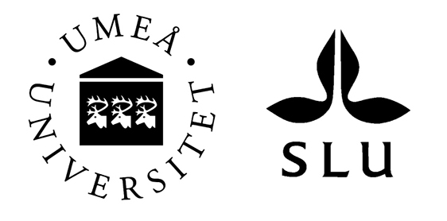**Sofie Degerman**, Department of Medical Biosciences, UmU

**15.50 – 16.00** **Conclusion and Poster prize**